|  |  |
| --- | --- |
| Date | 21 October 2022 |
| Student Name | ANANDHI.P |
| Student Register Number | 211419106026 |
| Maximum Marks | 2 Marks |

WOKWI WEB URL:

<https://wokwi.com/projects/347227855689613907>

**SNAPSHOTS OF SIMULATION:**

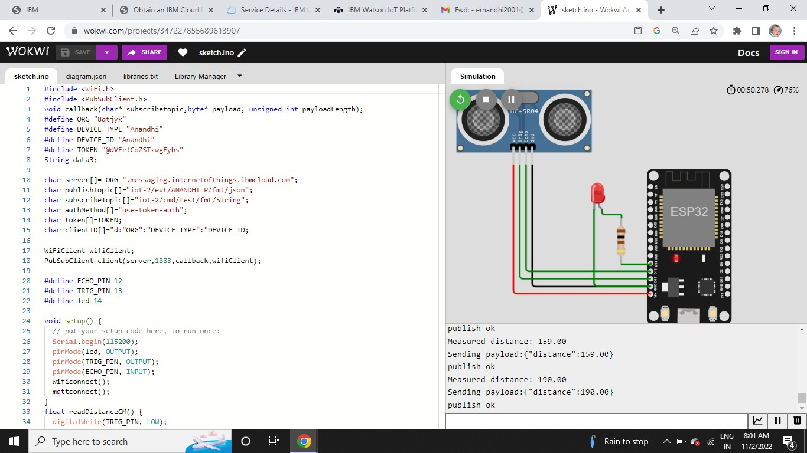

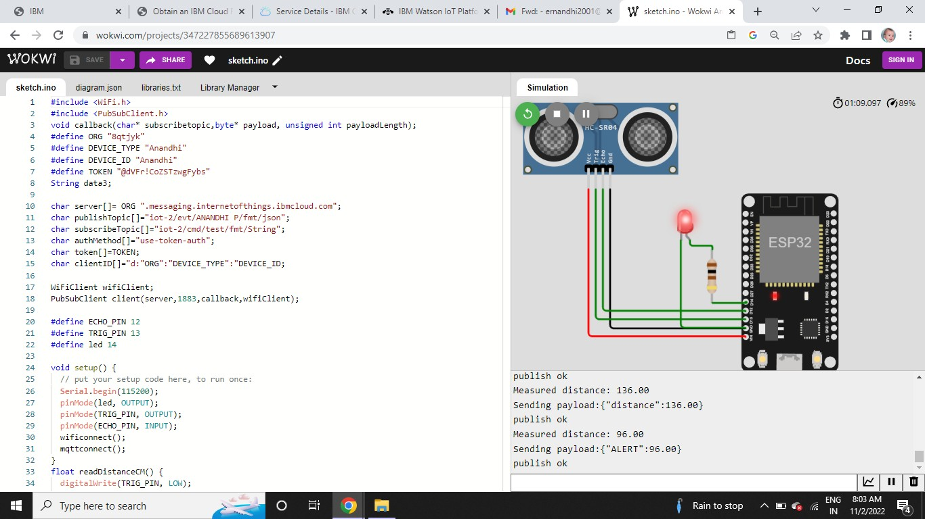

IMAGES OF IBM CLOUD:

